TAMANNA INSTITUTE
OF ALLIED HEALTH SCIENCES
CONGRATUALATION
GNM STUDENT
 |  | 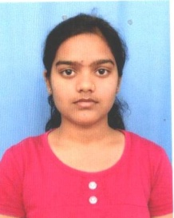 |  | 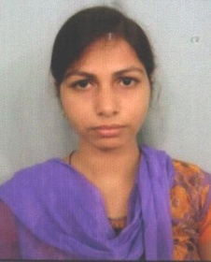
REKHA VISHWAKARMA  Joined Hospital: PSRI hospital- Malviya Nagar-New Delhi  Salary: 18400 CTC | MONIKA  Joined Hospital: JAIPUR GOLDEN-Punjabi Baug-Delhi  Salary: 17000 CTC | ANUPRIYA KUSHWAHA  Joined Hospital: PSRI hospital- Malviya Nagar-New Delhi  Salary: 17000 CTC | VIMLA PANDEY  Joined Hospital: KAILASH HOSPITAL-NOIDA  Salary: 15500 CTC | SAILJA SINGH  Joined Hospital: KAILASH HOSPITAL-NOIDA  Salary: 15500 CTC
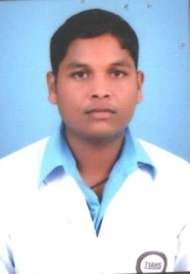 |  | 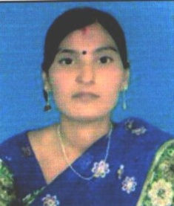 |  | 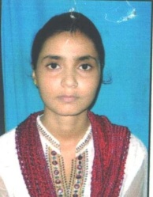
DHANANJAY  Joined Hospital: JAIPUR GOLDEN-Punjabi Baug-Delhi  Salary: 17000 CTC | SHASHIKALA CHAUHAN  Joined Hospital: KAILASH HOSPITAL-NOIDA  Salary: 15500 CTC | SANGEETA  Joined Hospital: PSRI hospital- Malviya Nagar-New Delhi  Salary: 17000 CTC | MAAN SINGH  Joined Hospital: JAIPUR GOLDEN-Punjabi Baug-Delhi  Salary: 17000 CTC | SANYA VISHWAKARMA  Joined Hospital : JAIPUR GOLDEN-Punjabi Baug-Delhi  Salary: 17000 CTC
 | 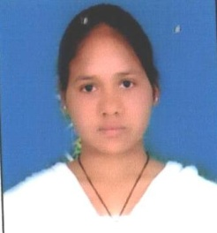 | 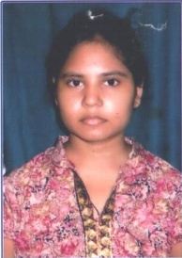 | 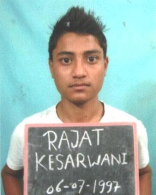
 | SADHANA RAJBHAR  Joined Hospital: PSRI hospital- Malviya Nagar-New Delhi  Salary: 17000 CTC | SARASWATI SHUKLA  Joined Hospital: JAIPUR GOLDEN-Punjabi Baug-Delhi  Salary: 17000 CTC | RAJAT KESARVANI  Joined Hospital: JAIPUR GOLDEN-Punjabi Baug-Delhi  Salary: 17000 CTC

